Task 01 :

What is a process?

Process is an instance of the Java application. When you run a program , JVM is launched.  
In this case , JVM is a process launched by OS.

Task02 :

What is a thread?  
  
Thread is a lightweight path of a execution within a process, it doesn’t take much memory.   
Multiple threads can run in parallel to improve the performance.

Task 03:  
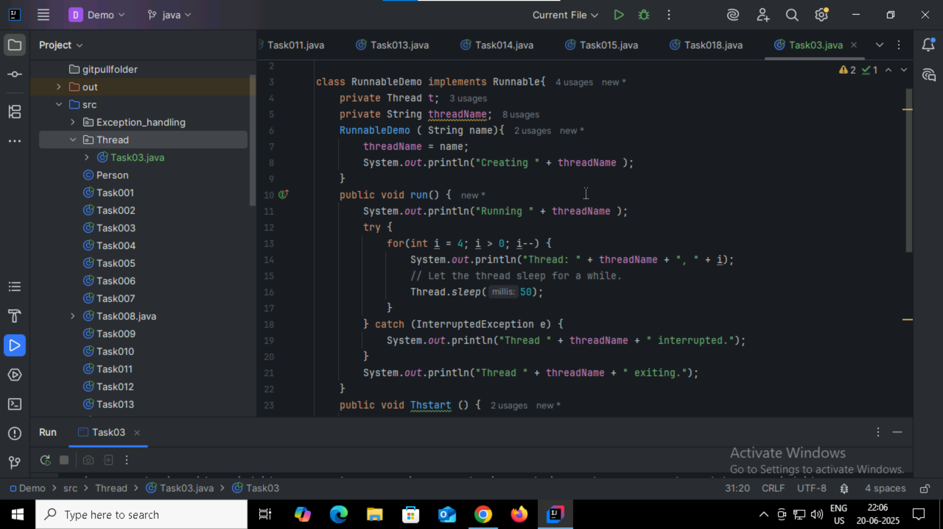

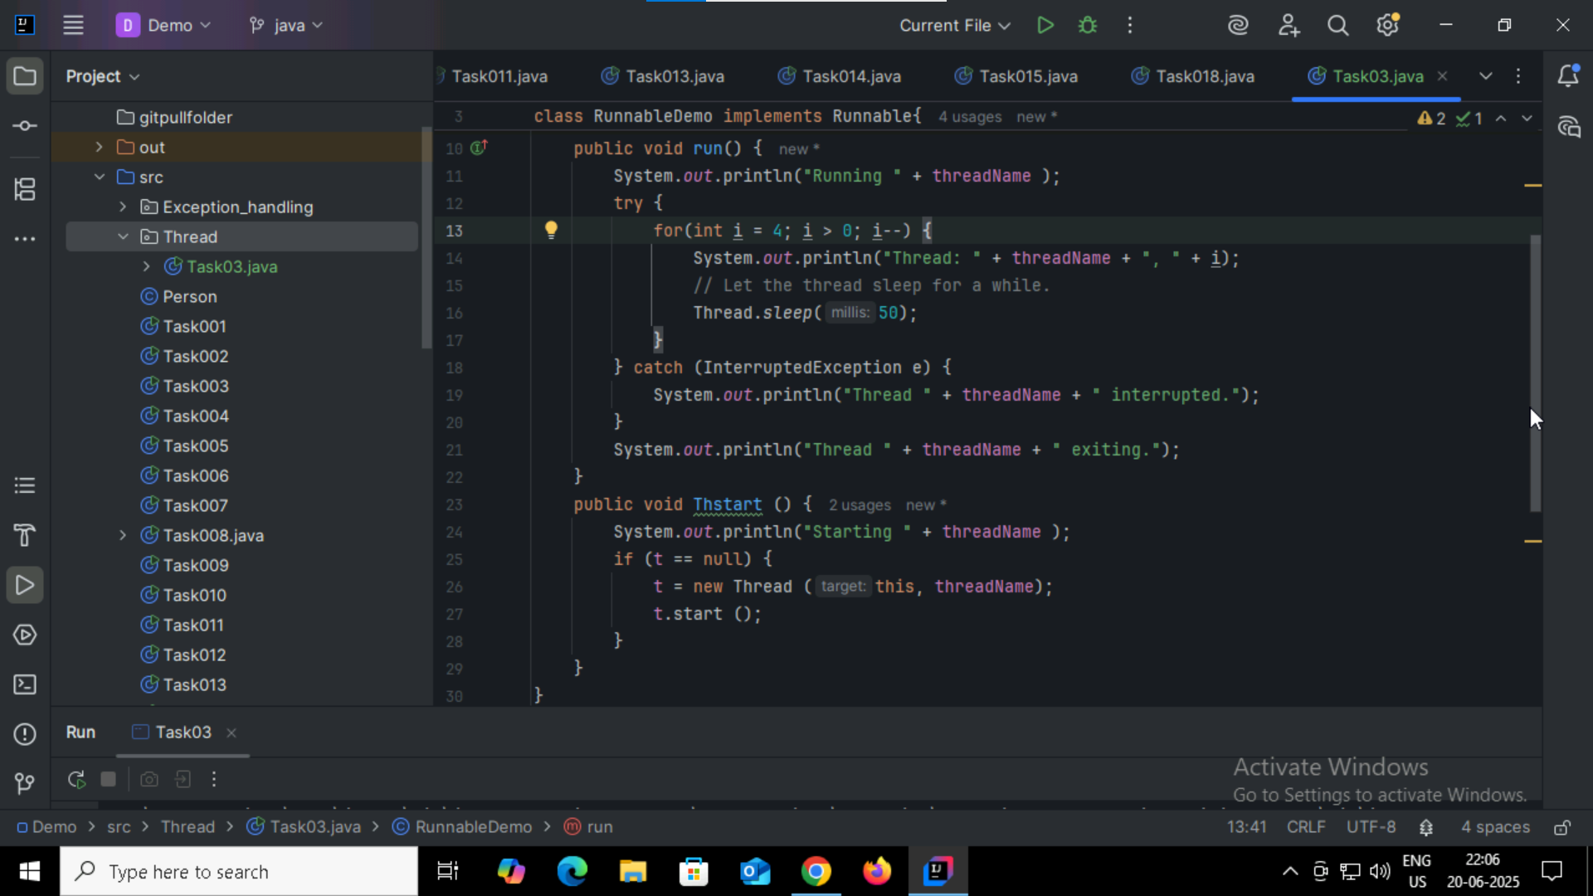

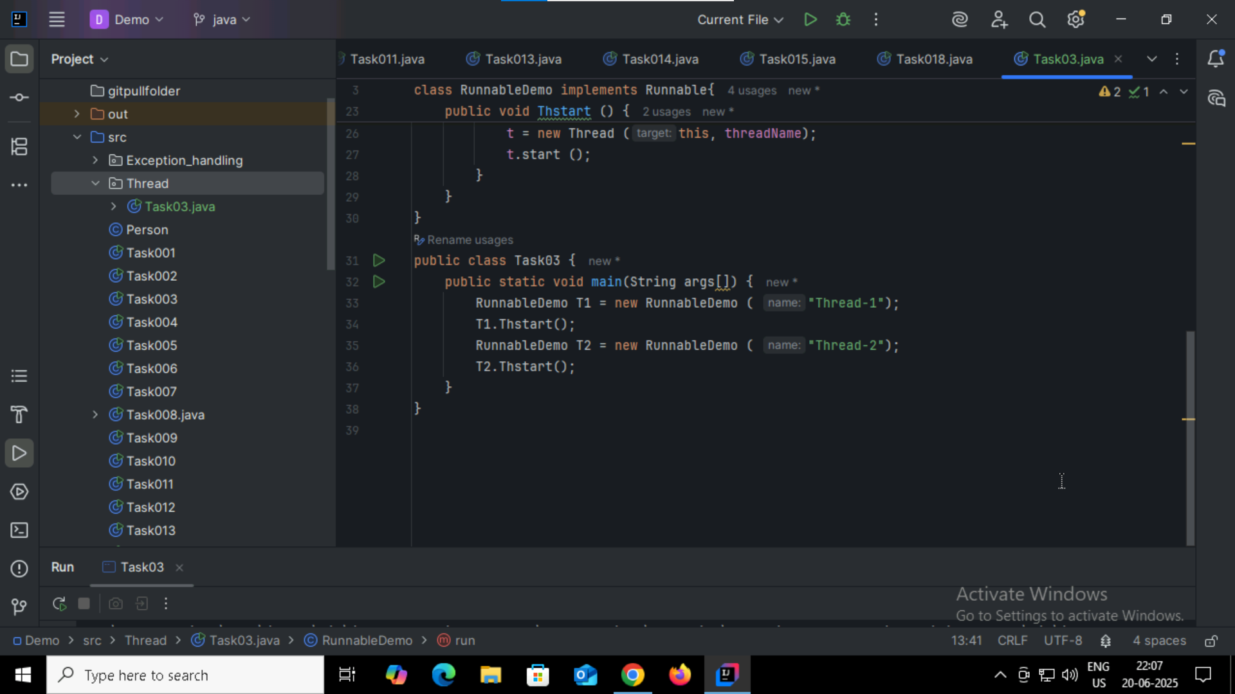

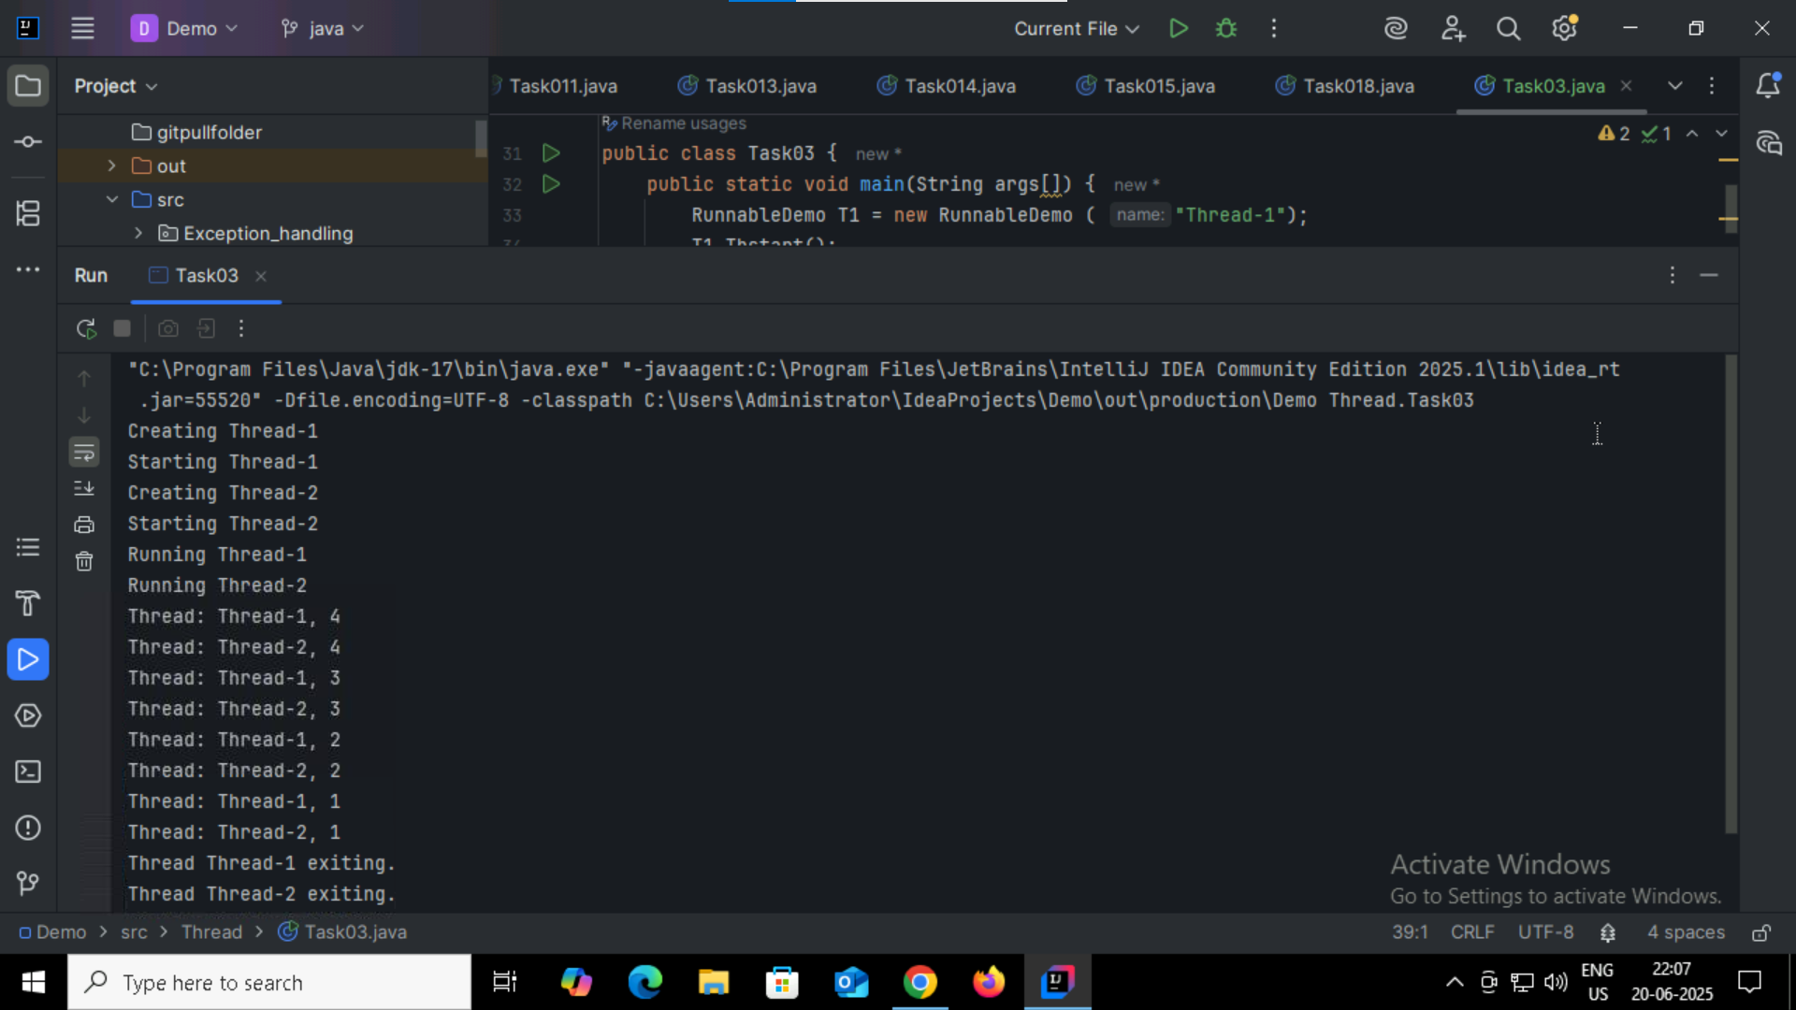

Task04:

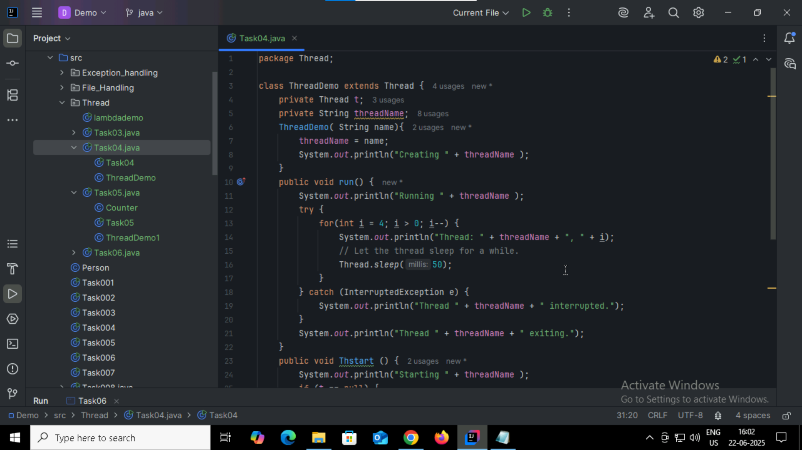

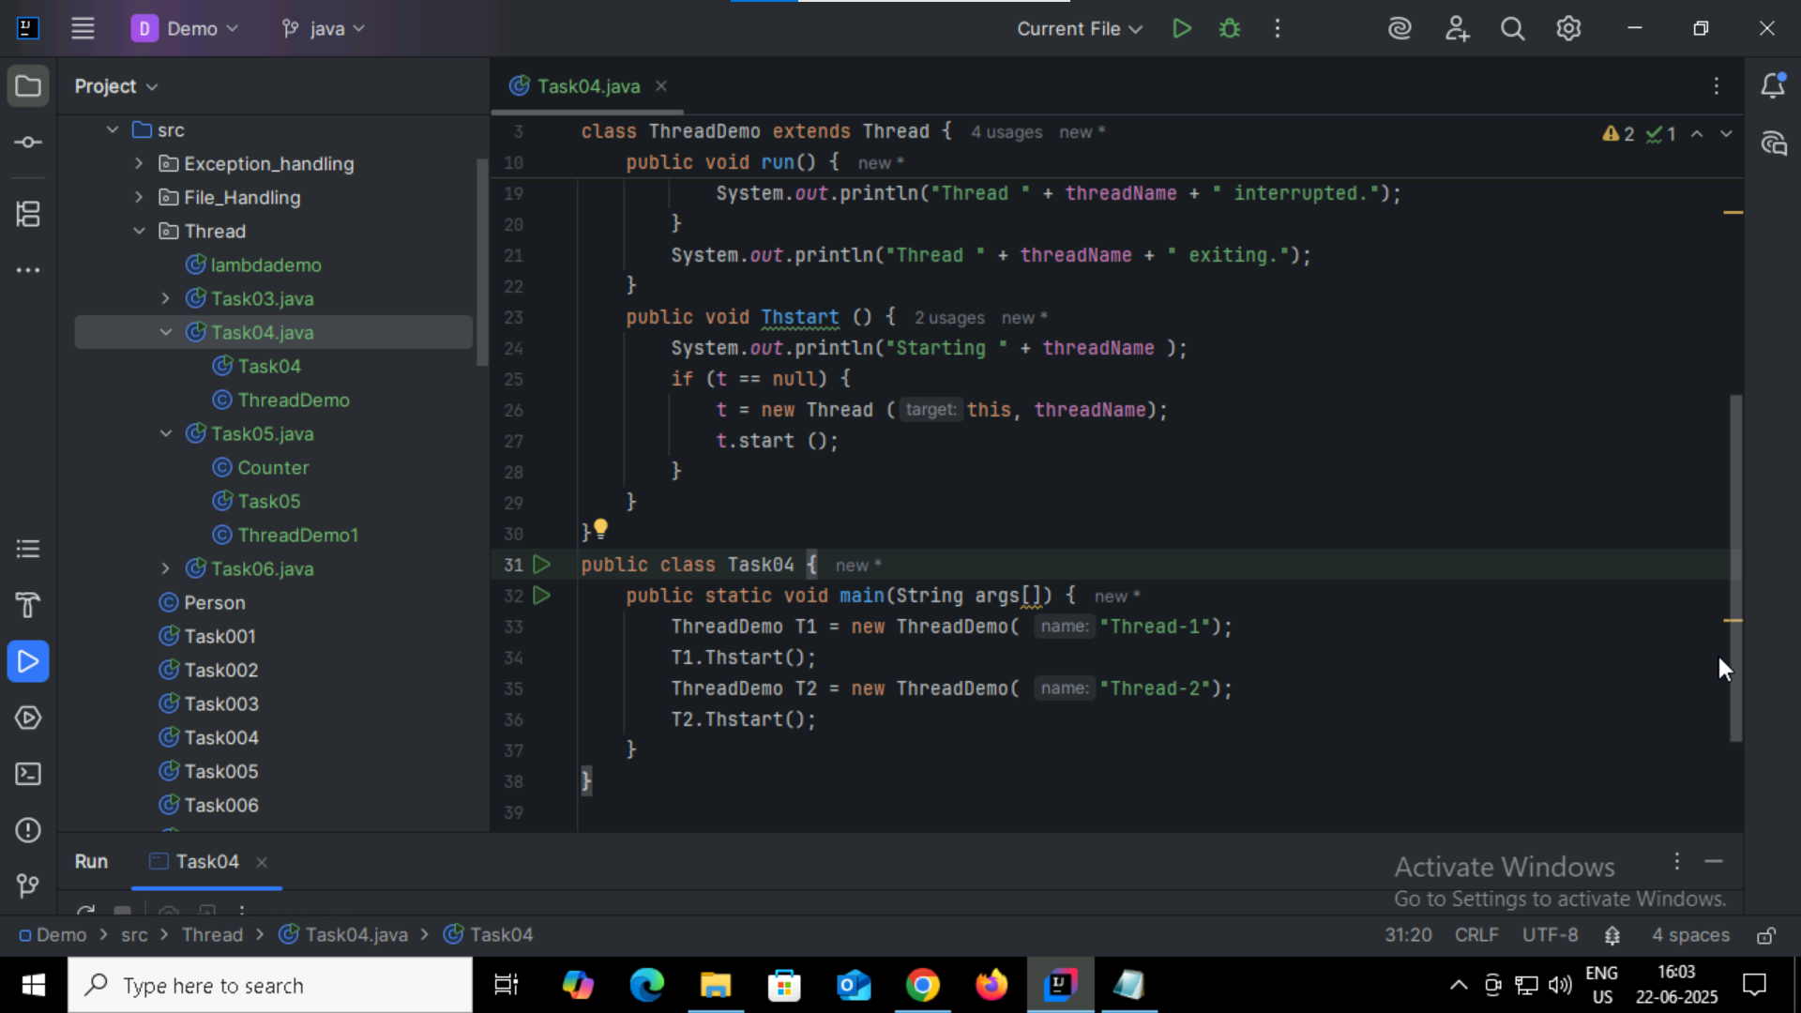

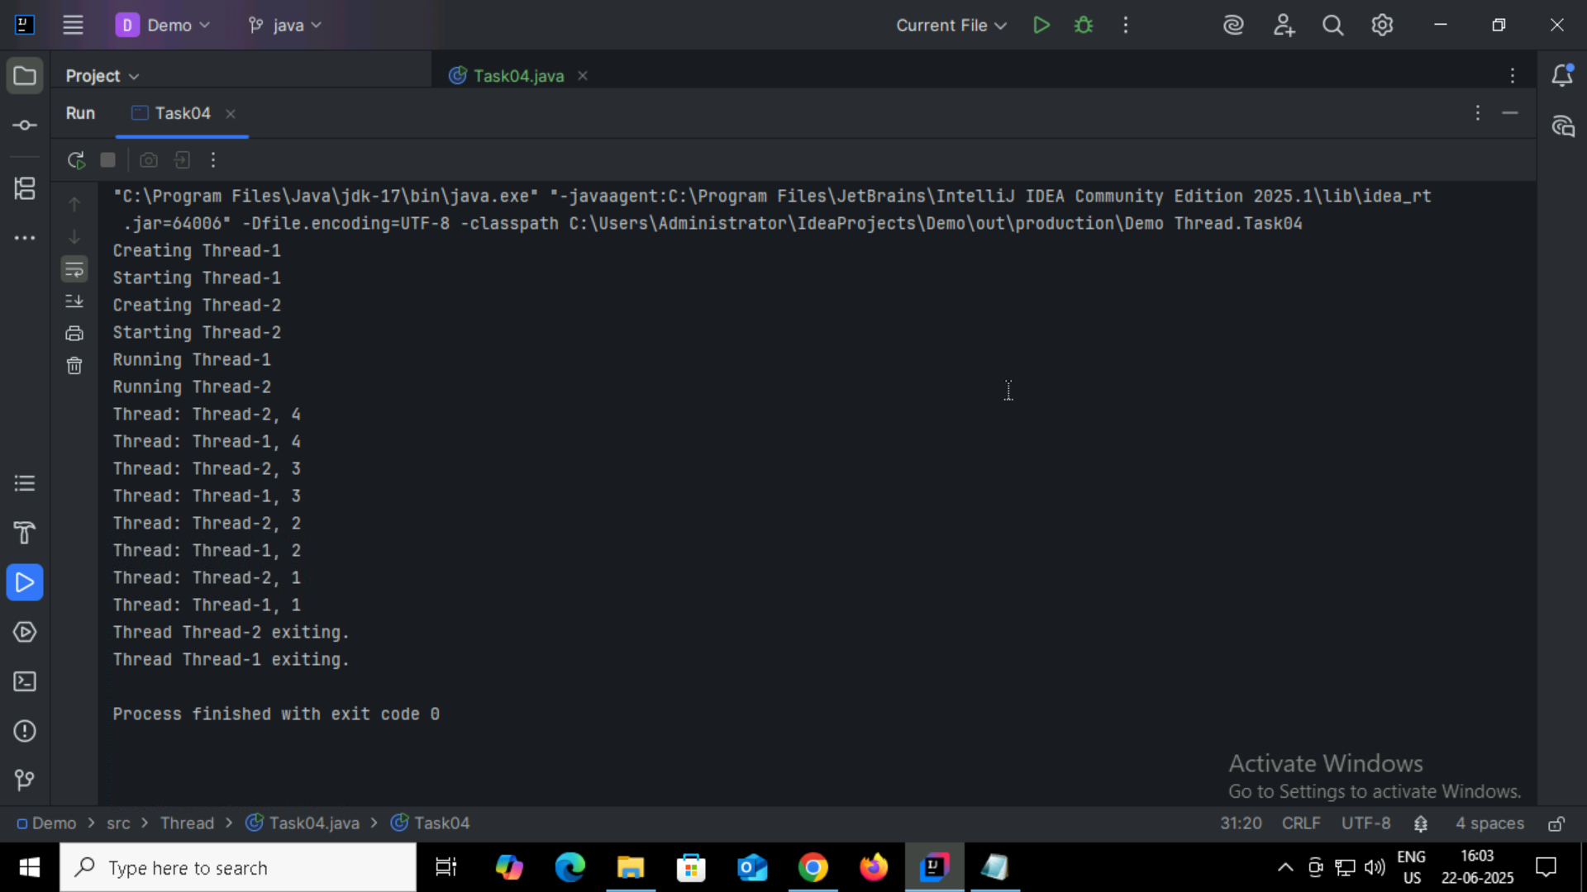

Task05:

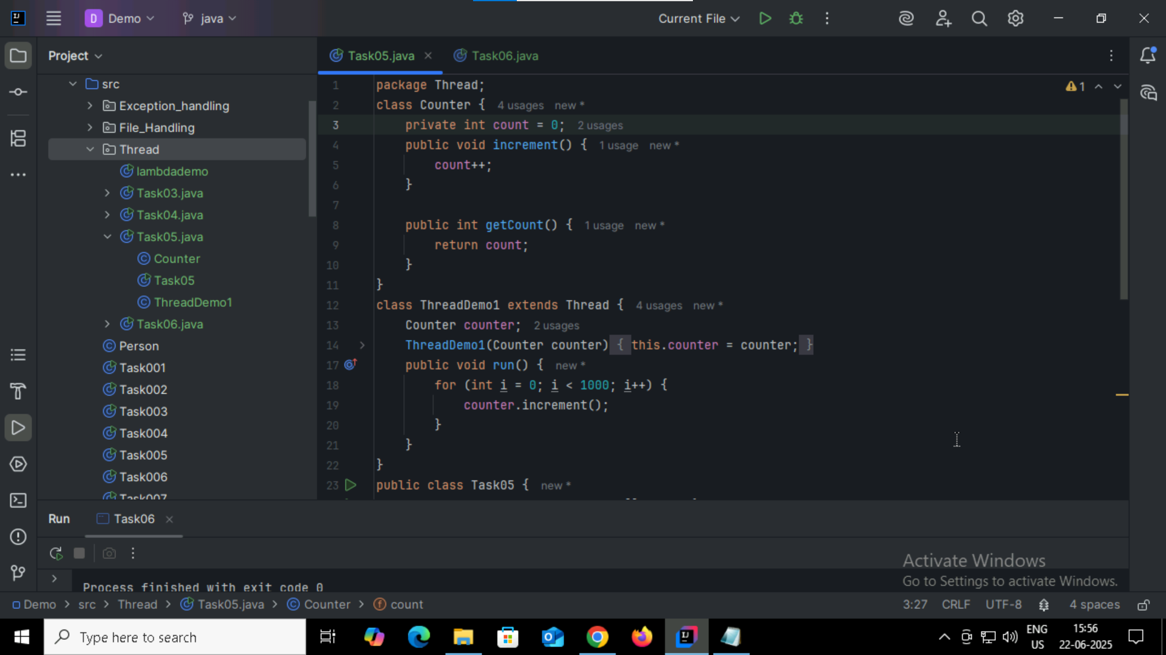

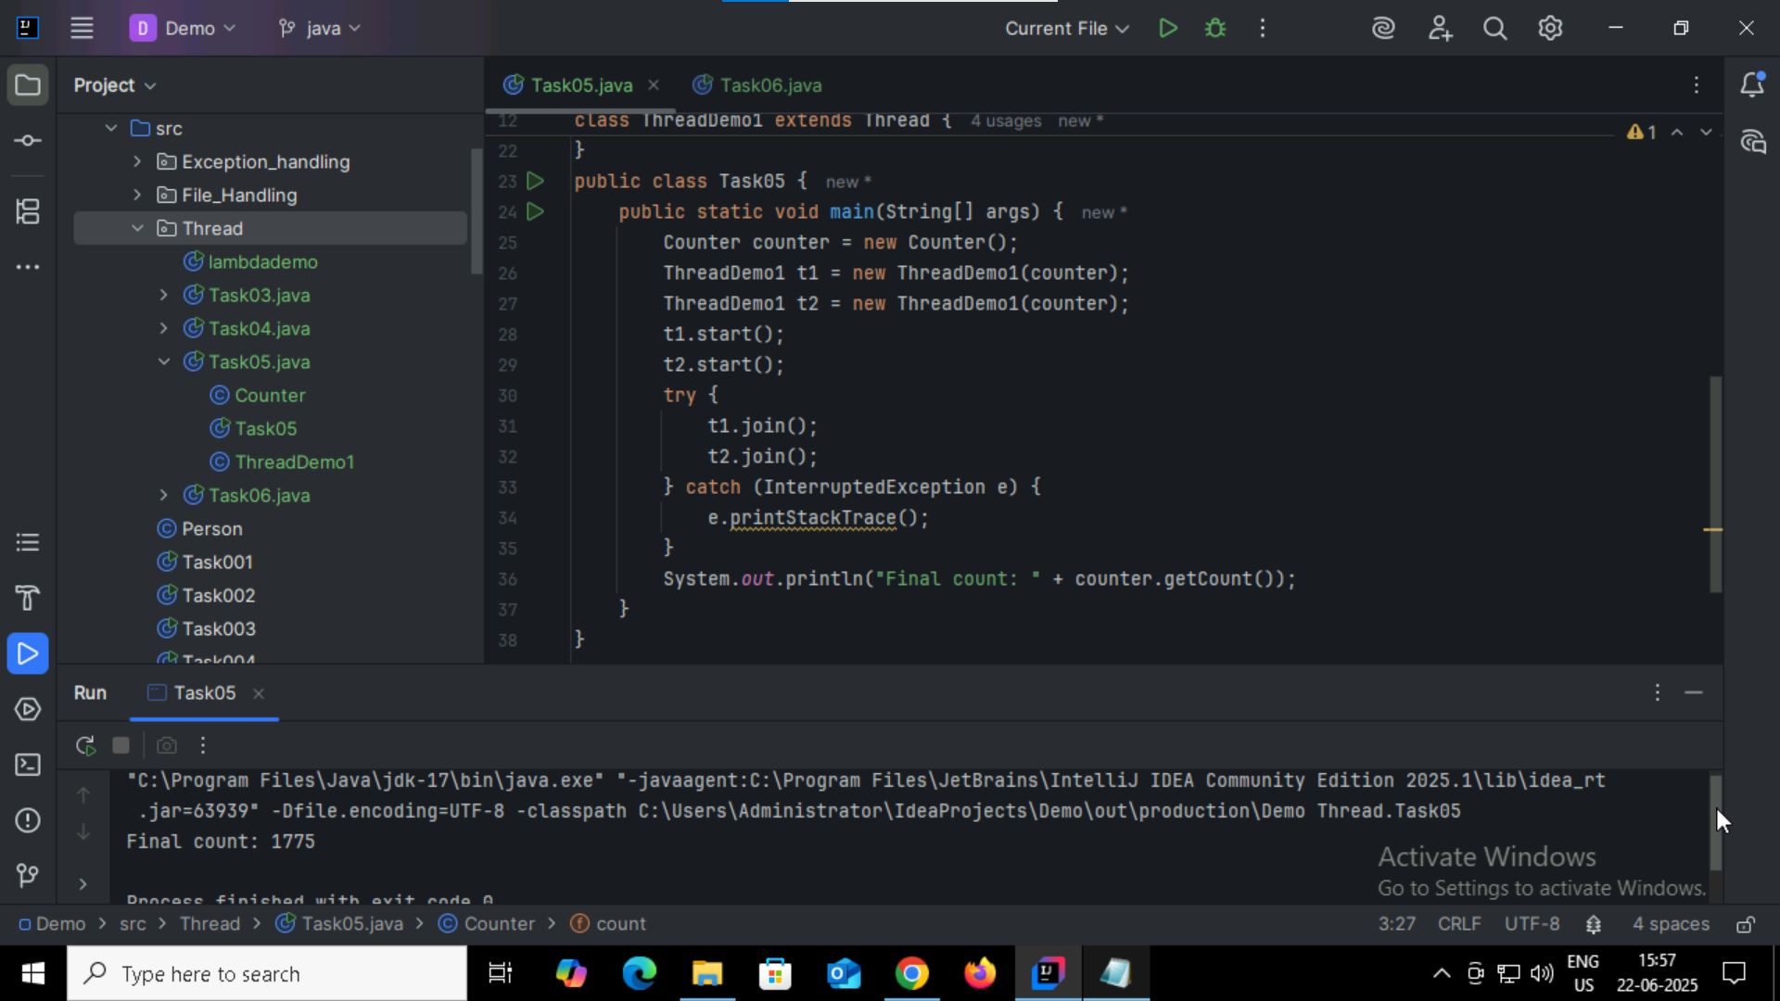

In this method, we won’t get the desired counter result everytime , when two threads execute simultaneously, they overwrite each other’s results.  
  
Task06:

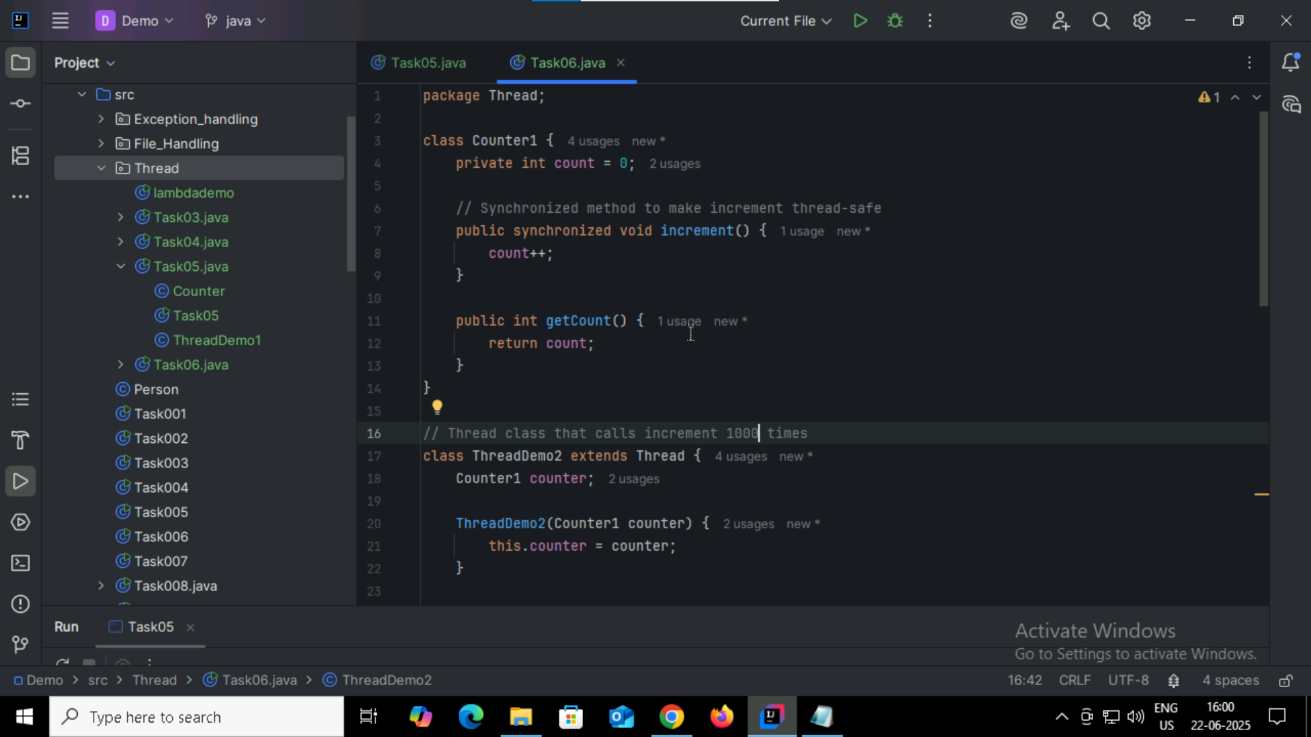

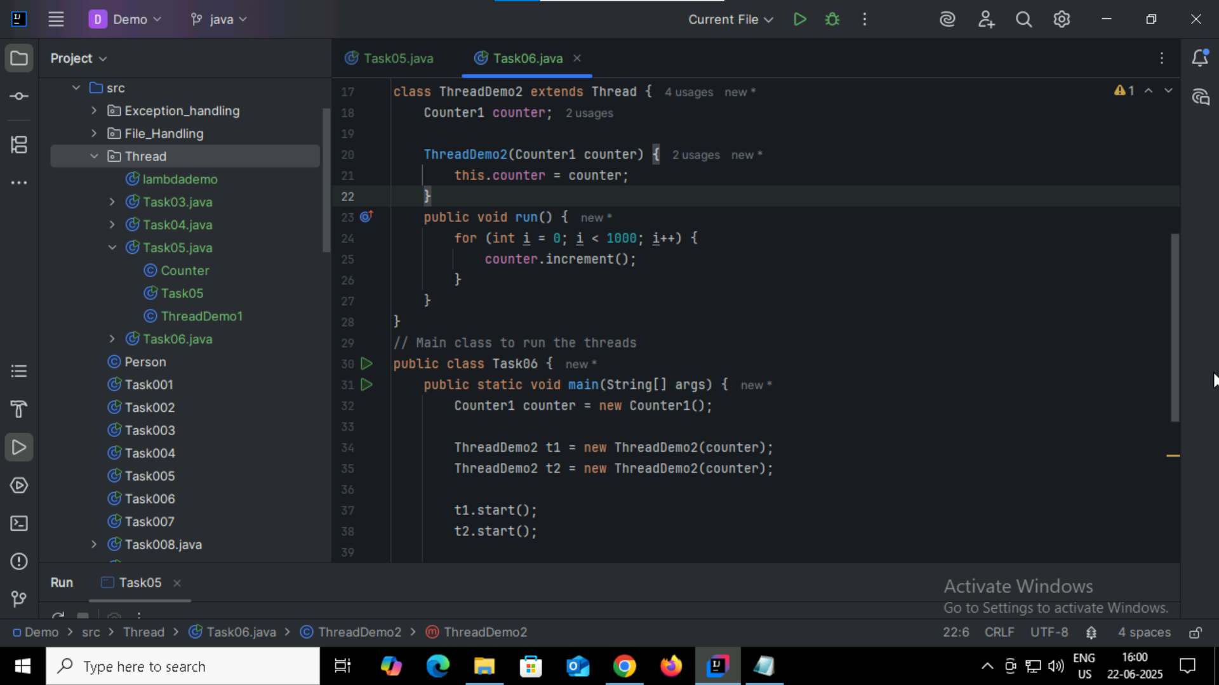

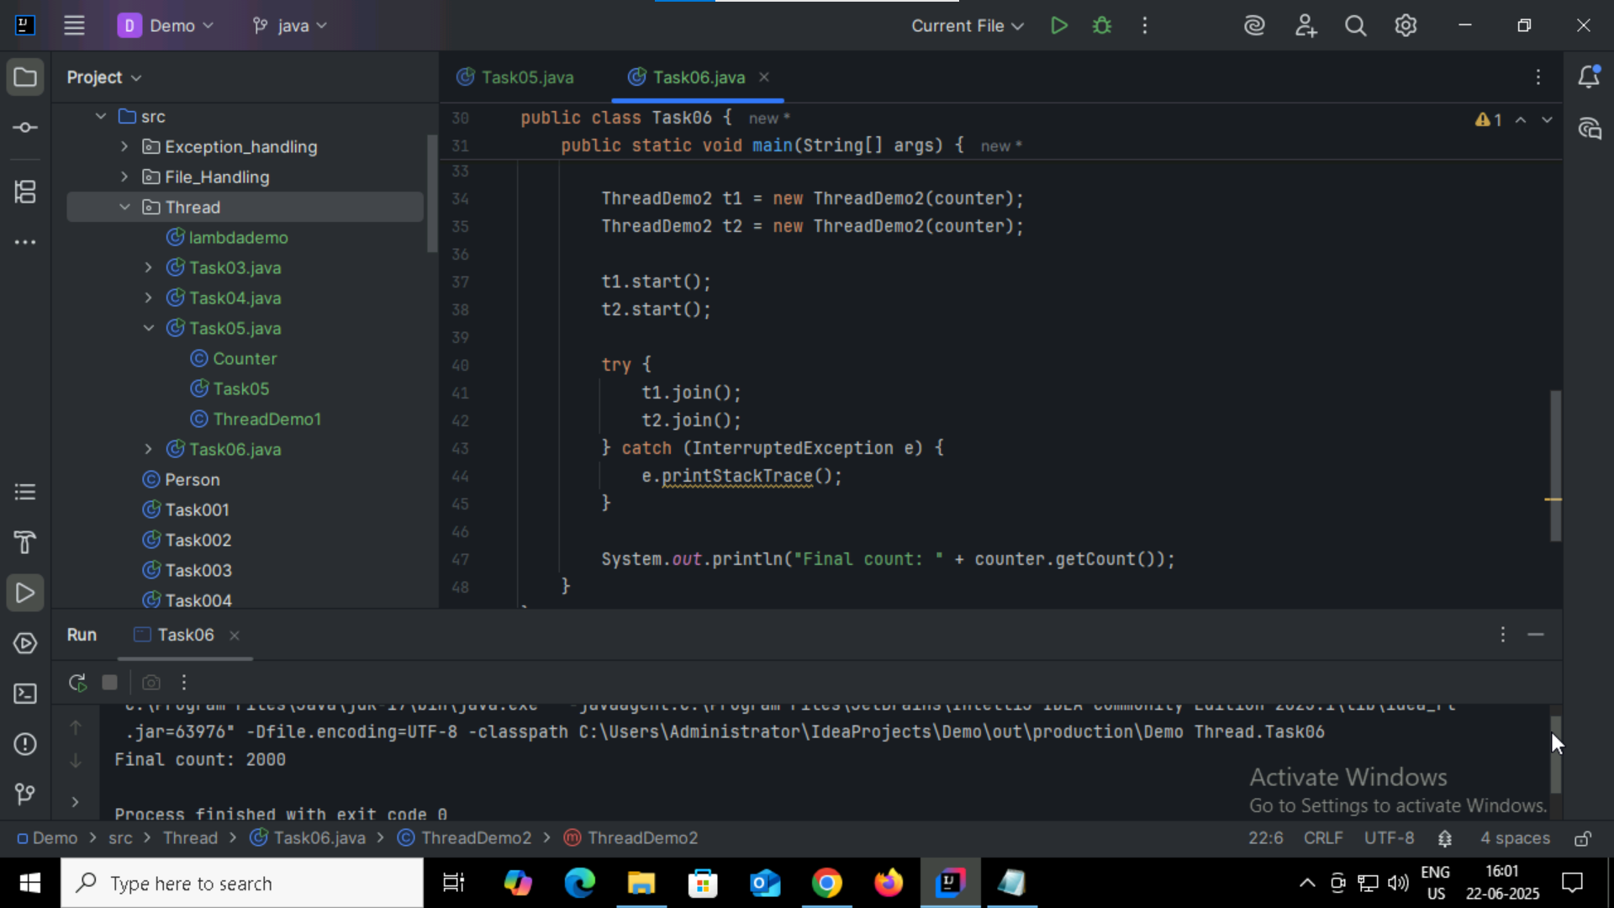

By using synchronized method, it ensures that only one thread runs at a time.

Task07:

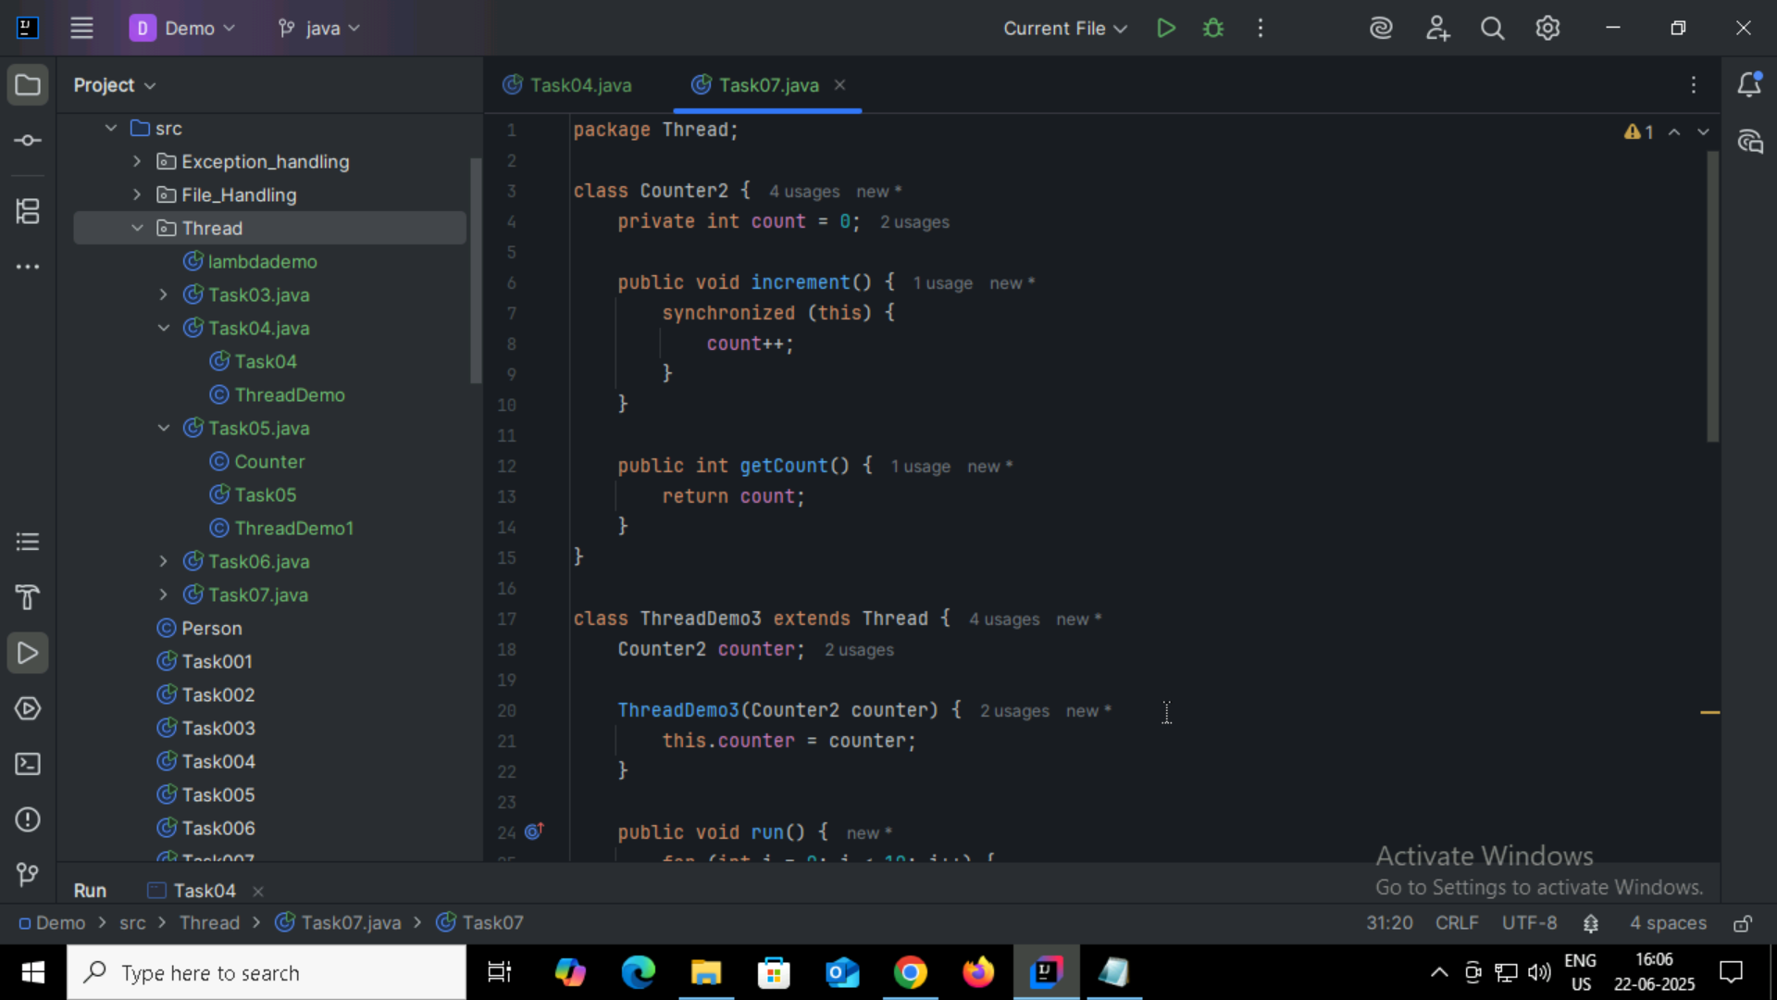

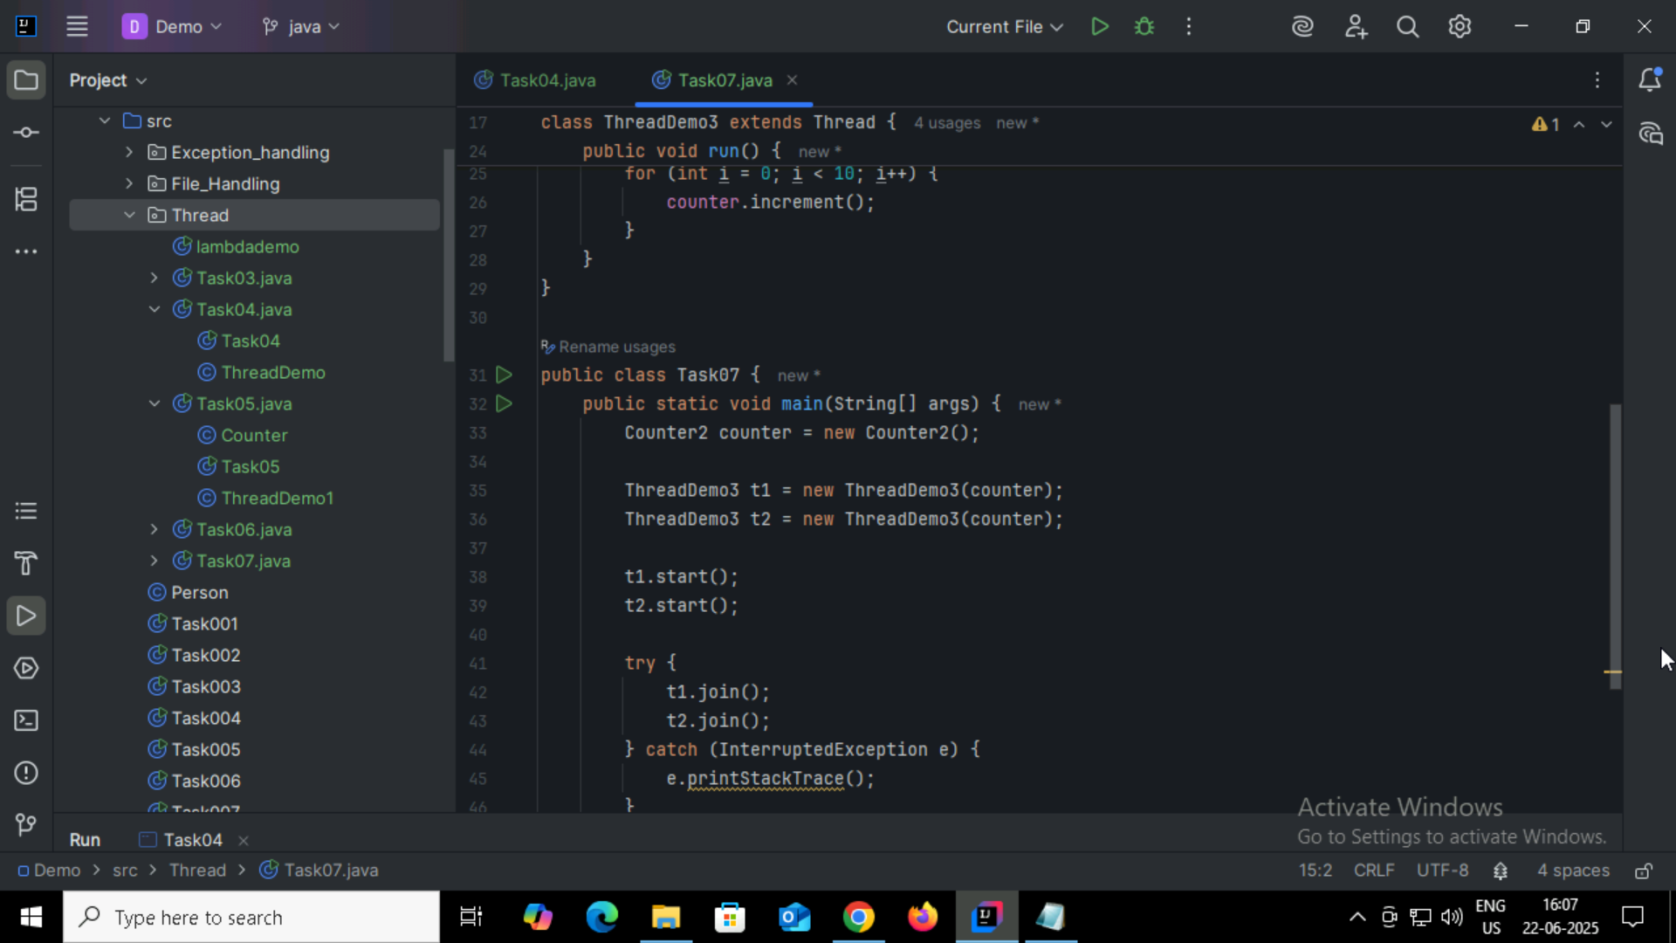

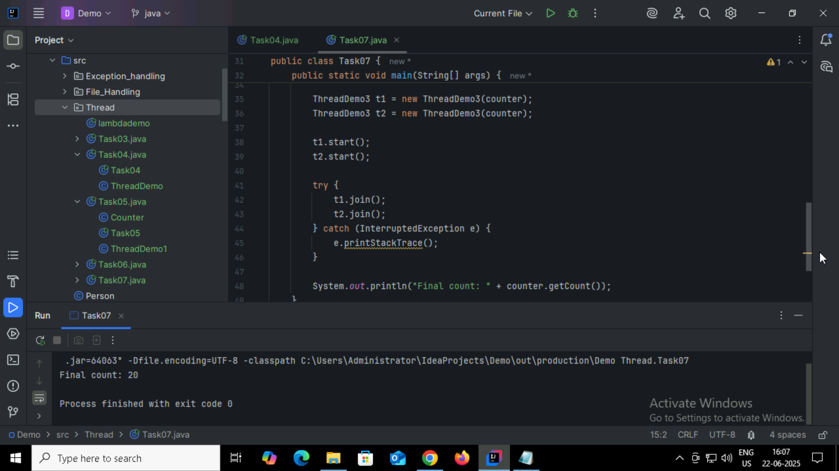

Instead of synchronizing method, synchronizing the particular block.

Task08:

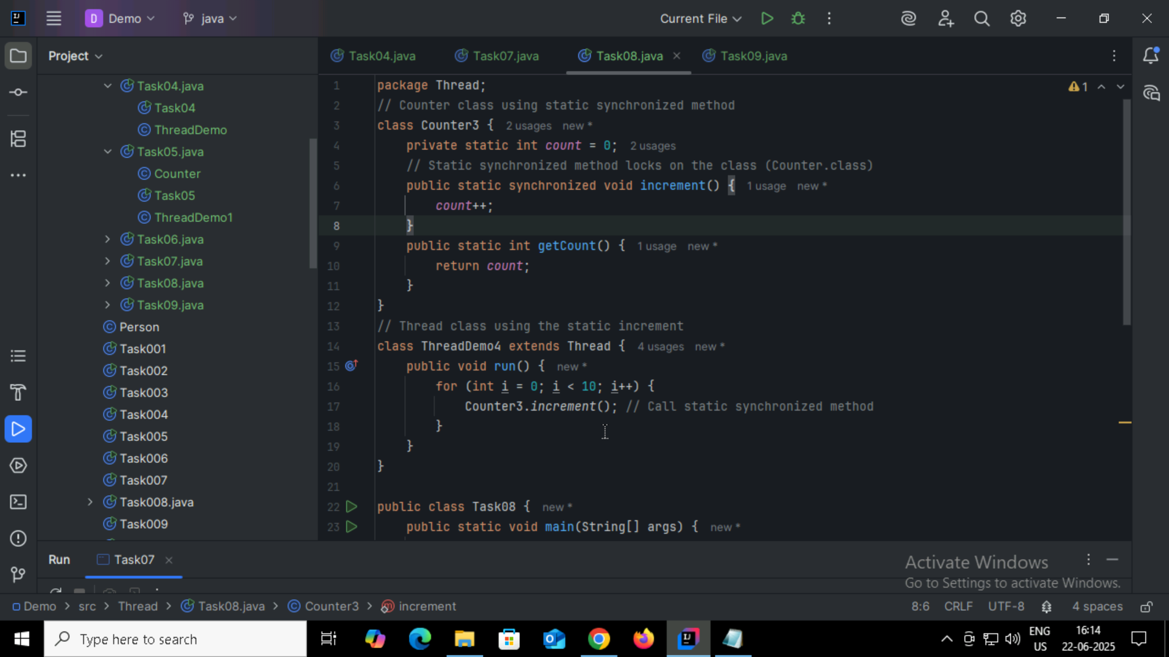

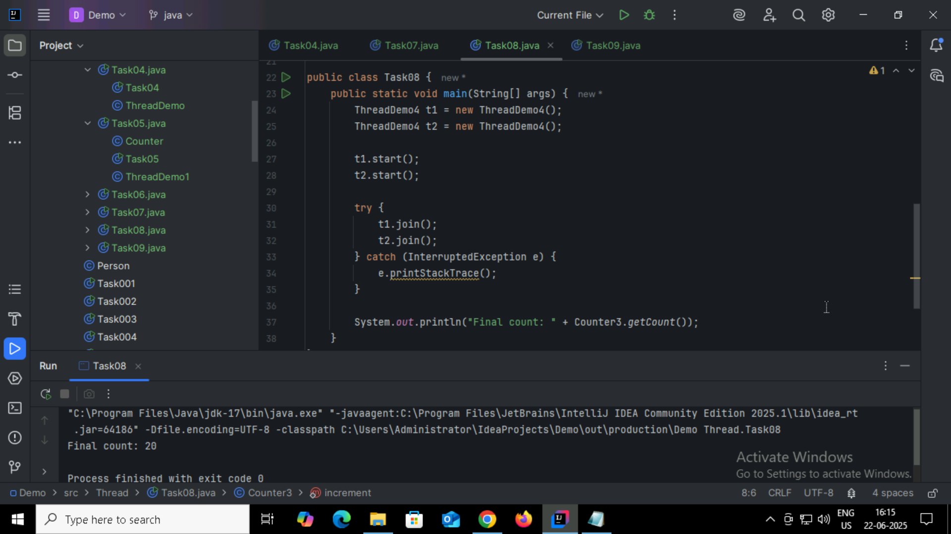

Task09:

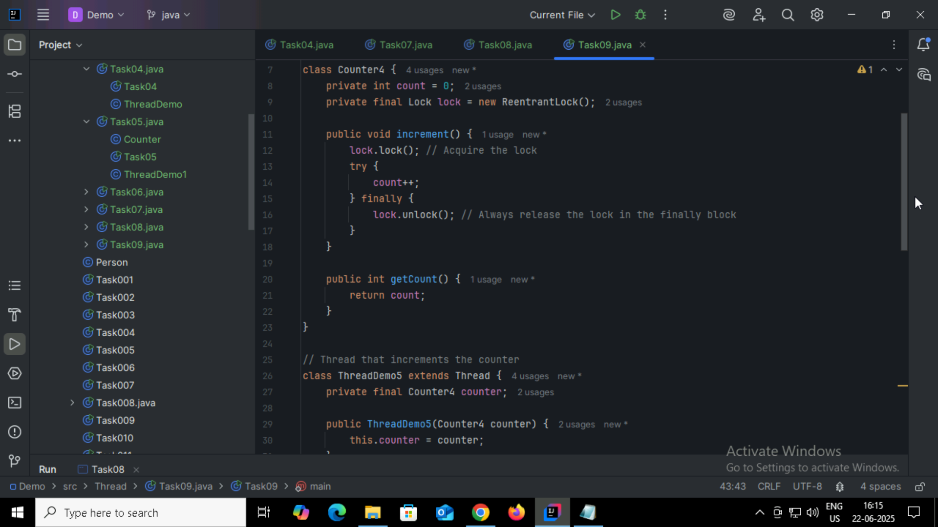

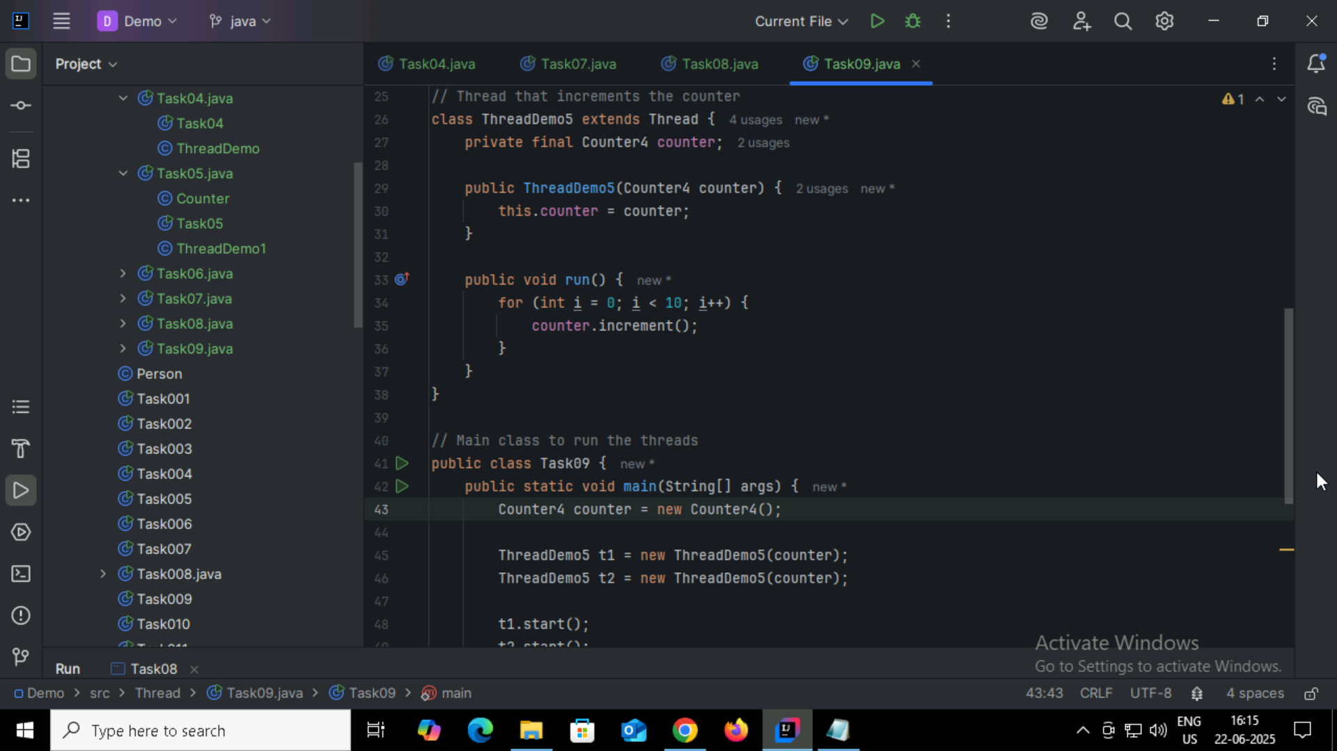

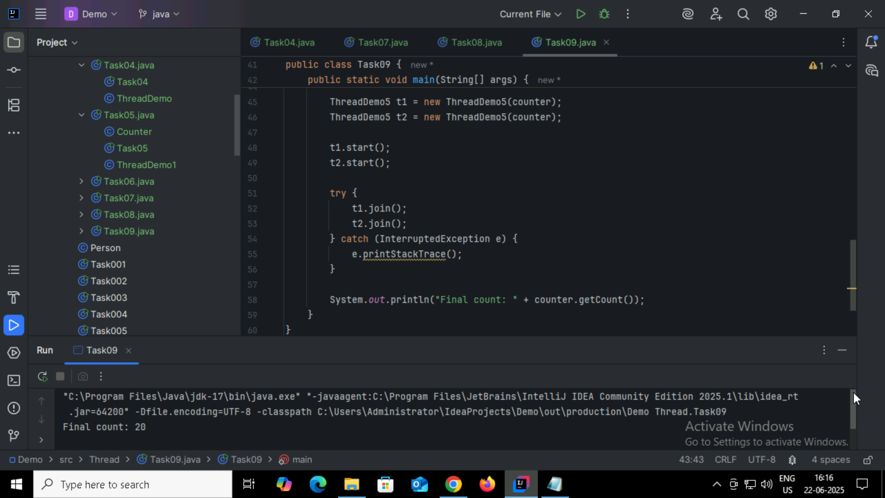

Task10:

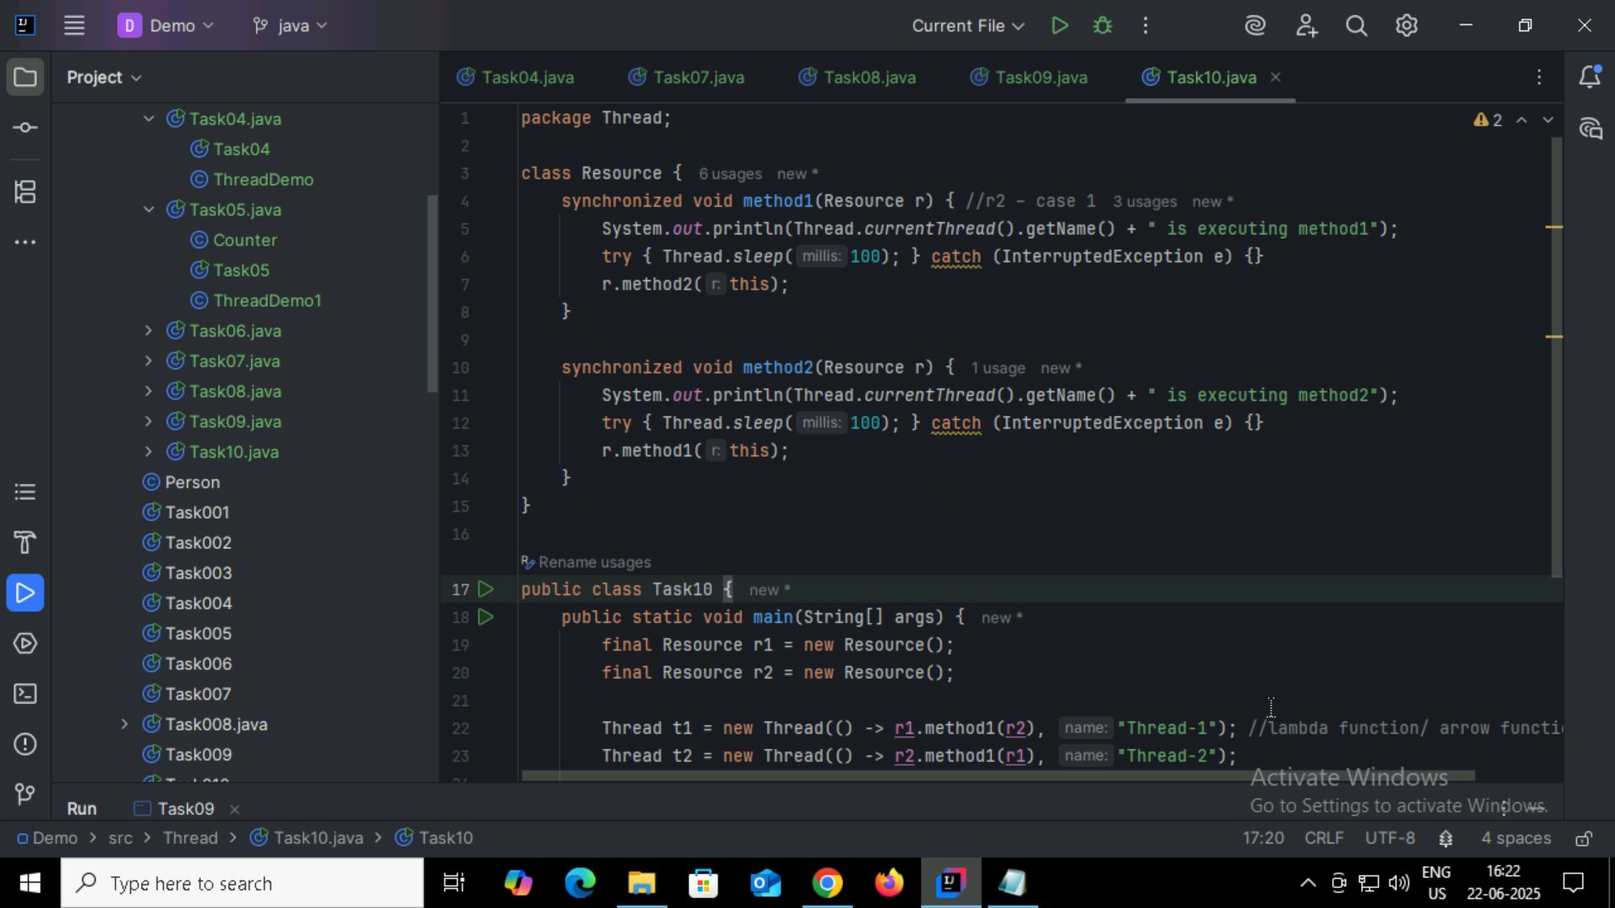

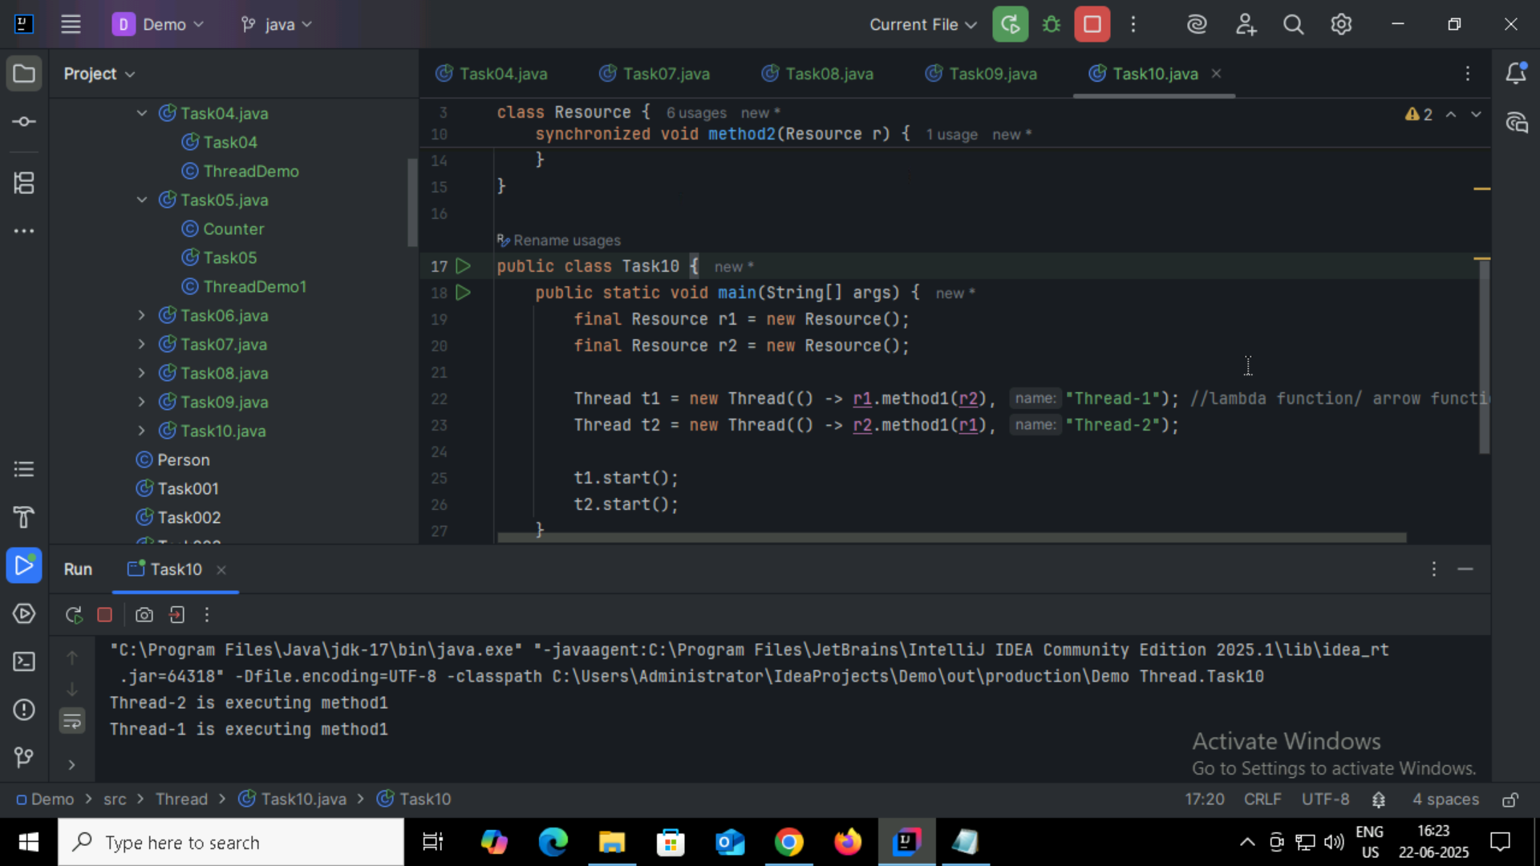

Task11:

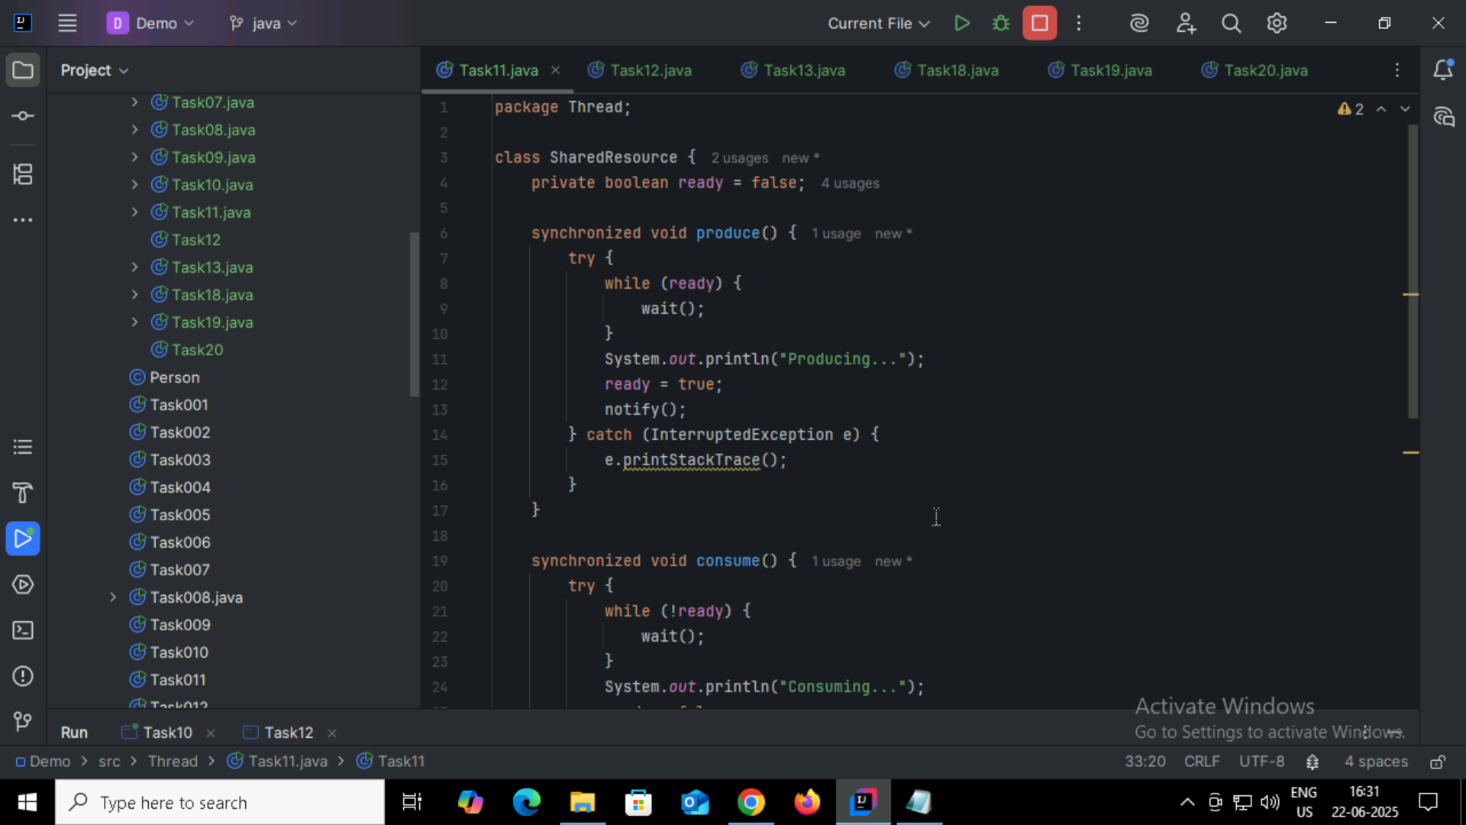

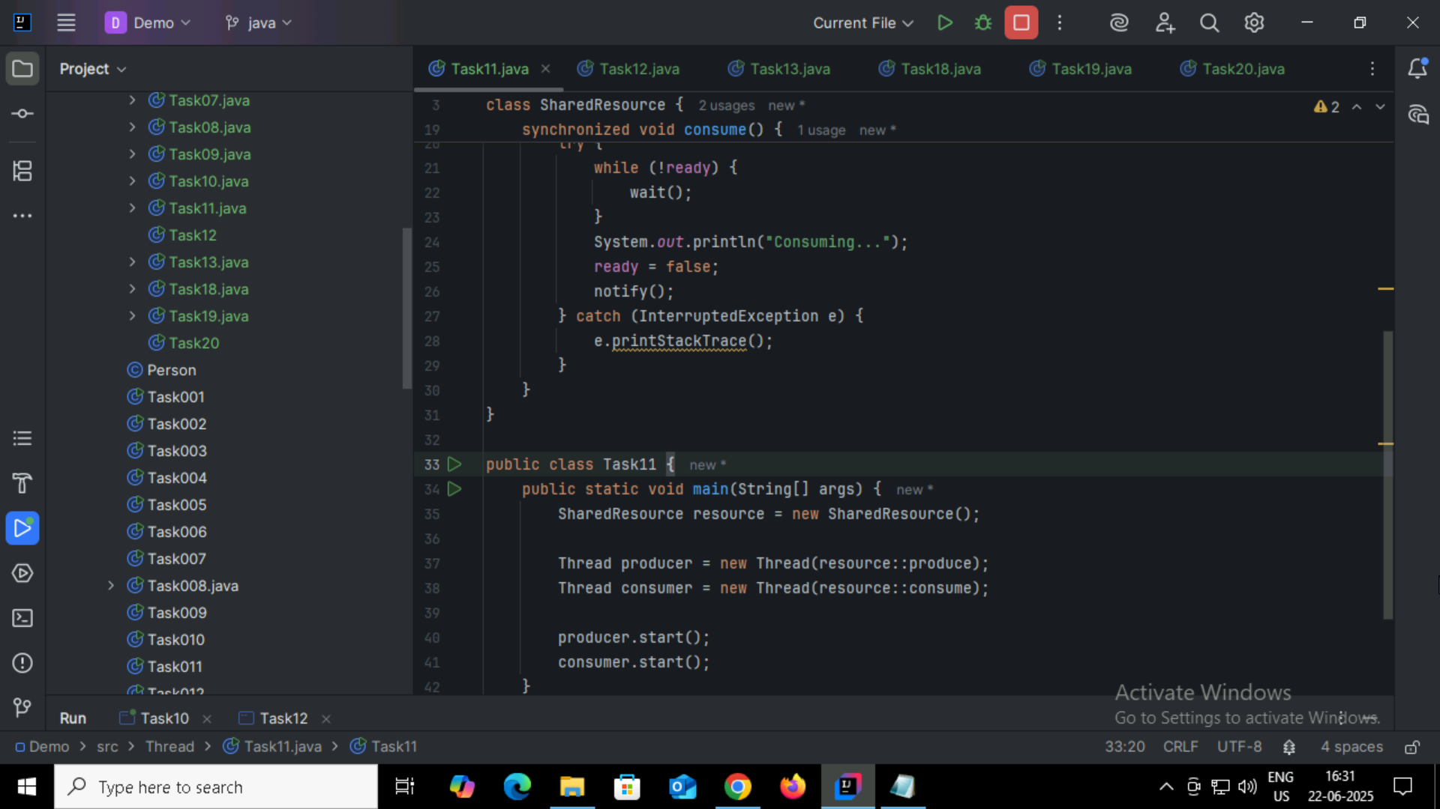

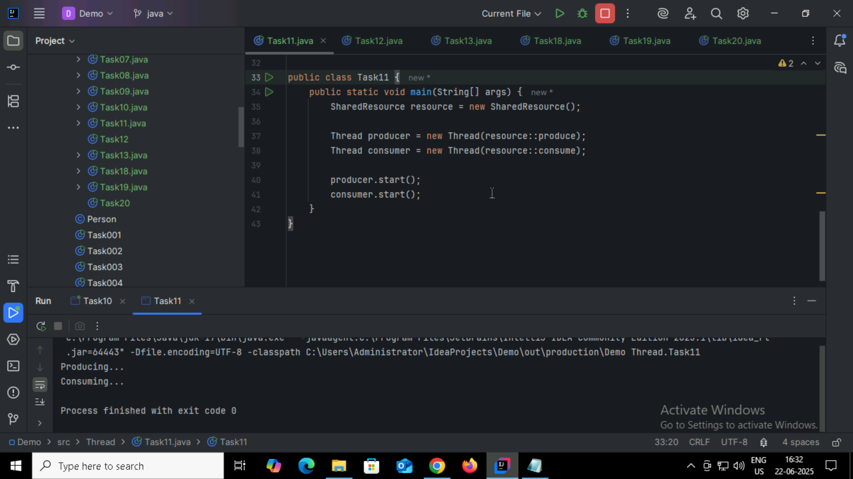

Task12:

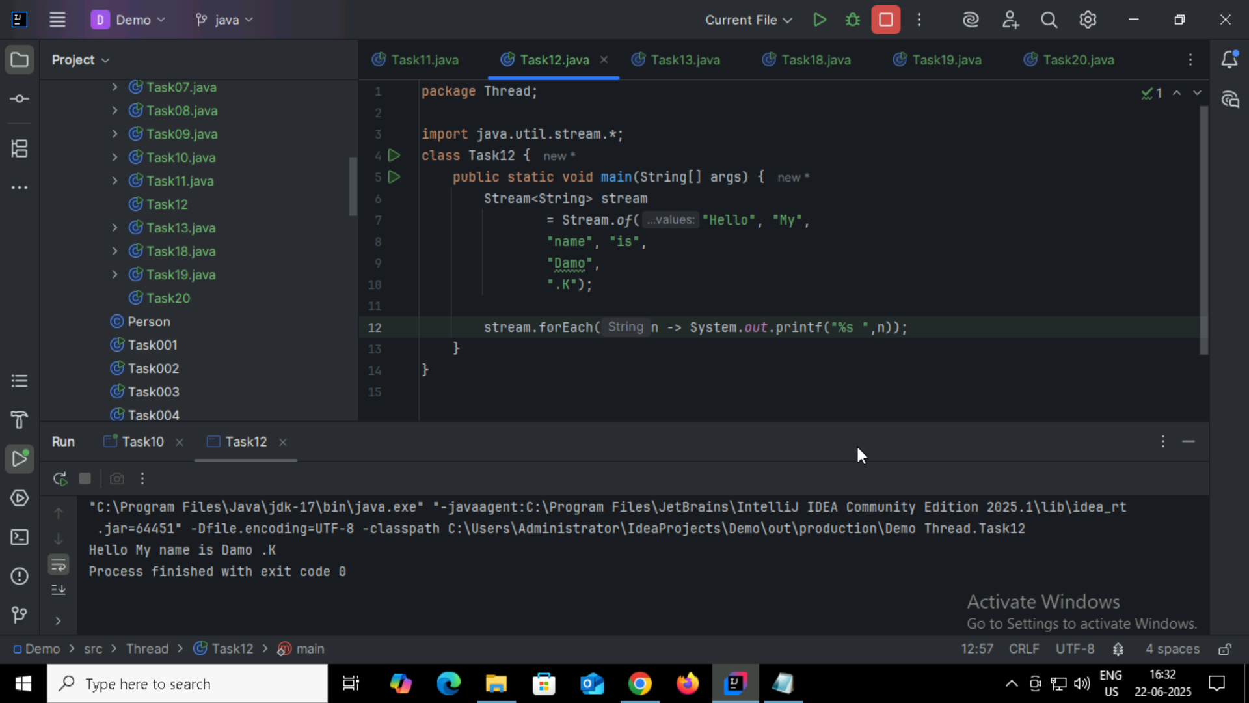

Task13:

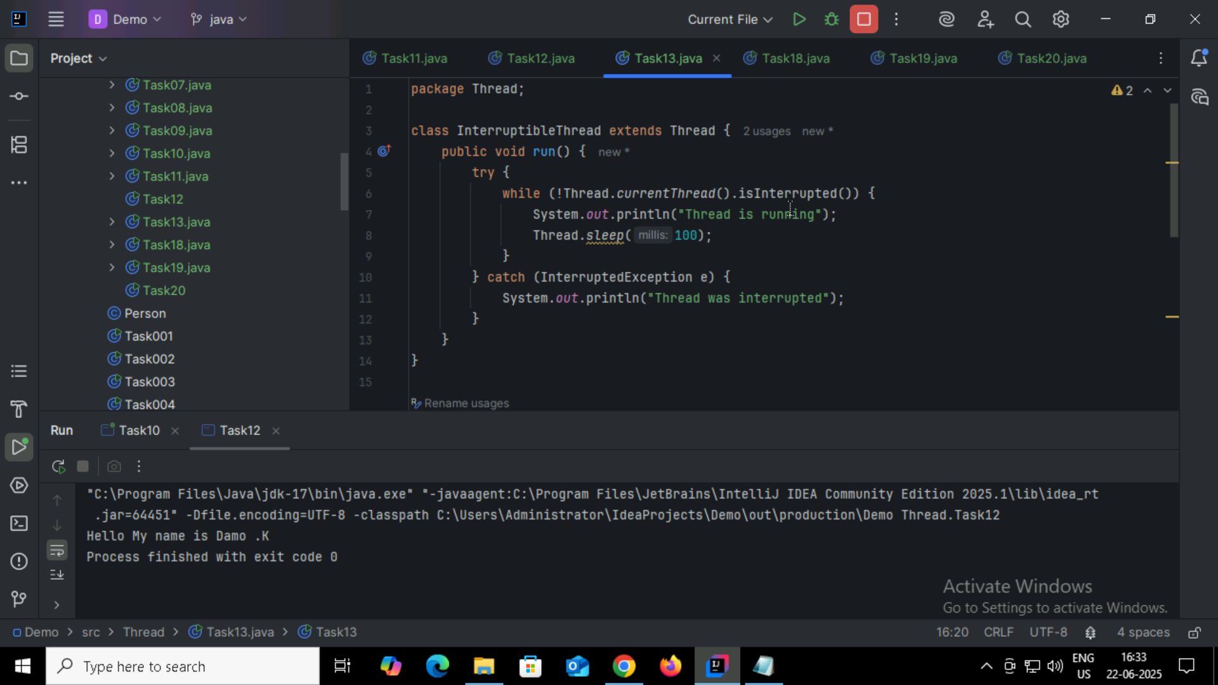

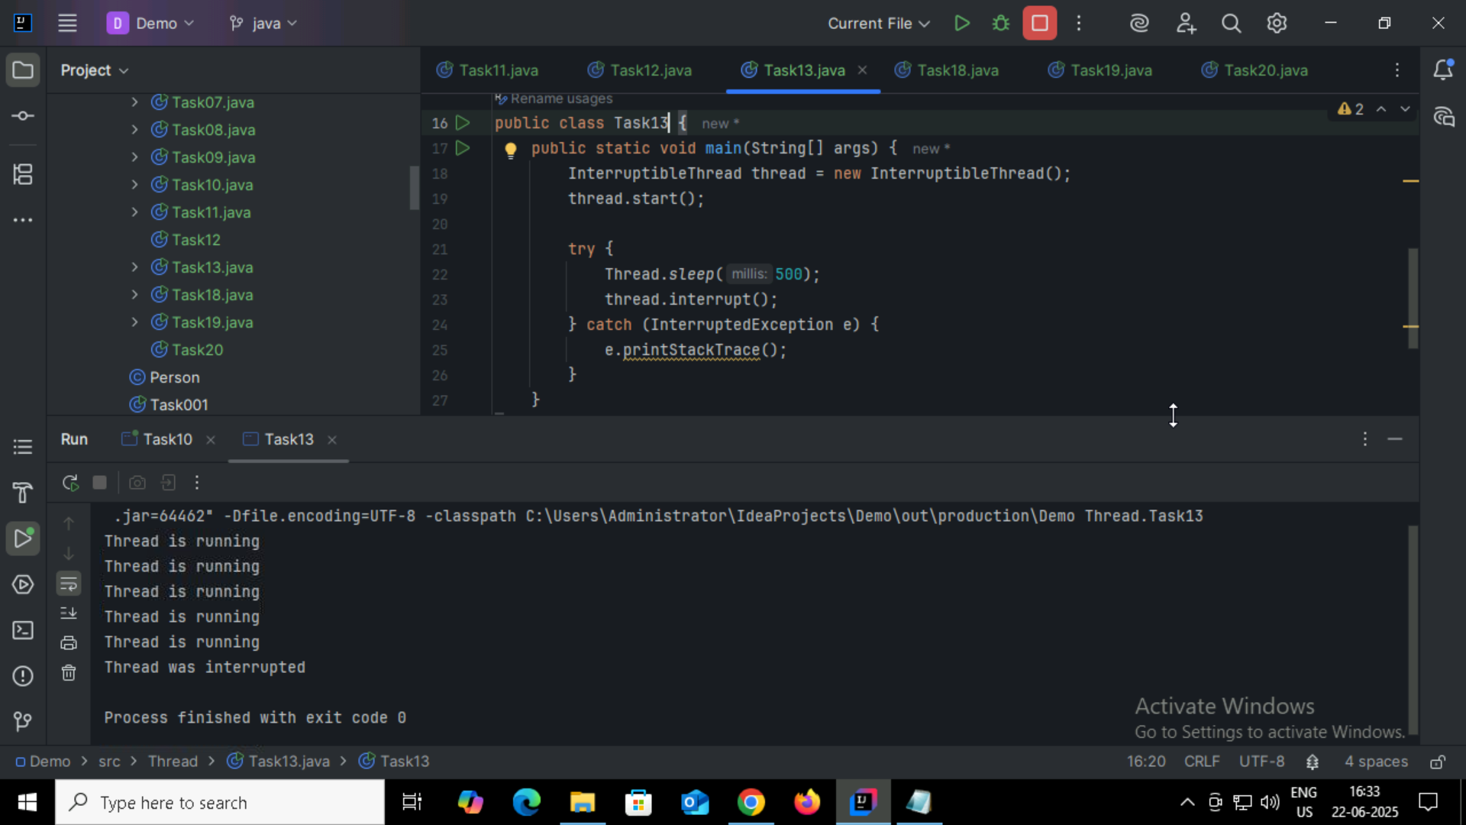

Task14:

Daemon Threads:  
It’s a background thread that supports other processes . These are low priority service threads  
JVM will terminate as soon as the user threads finish executing, even if the daemon threads are still running.

Task15:

Debugging tools in Java

IDE Debuggers:  
Eclipse

IntelliJ

NetBeans

Java Debugger JDB

Maven Surefire Plugin

Gradle Test Debugging

Task16:

Types of errors in Java

Syntax Errors – Missing ; , Invalid keywords

Runtime Exceptions – NullPointerException,ArithmeticException

Checked Exceptions – IOException

Task17:

Stacktrace – It is a report of method calls that leads to exception or error.  
It shows where the error has occurred along with the line number and the number of methods that are executing.

Task18:

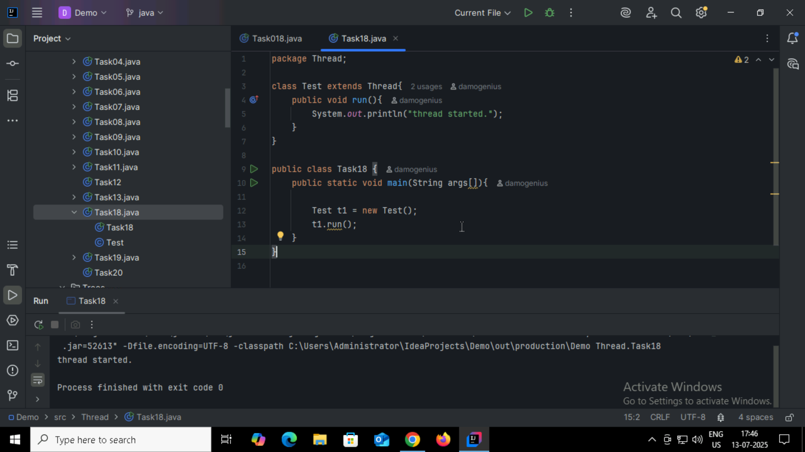

Task19:

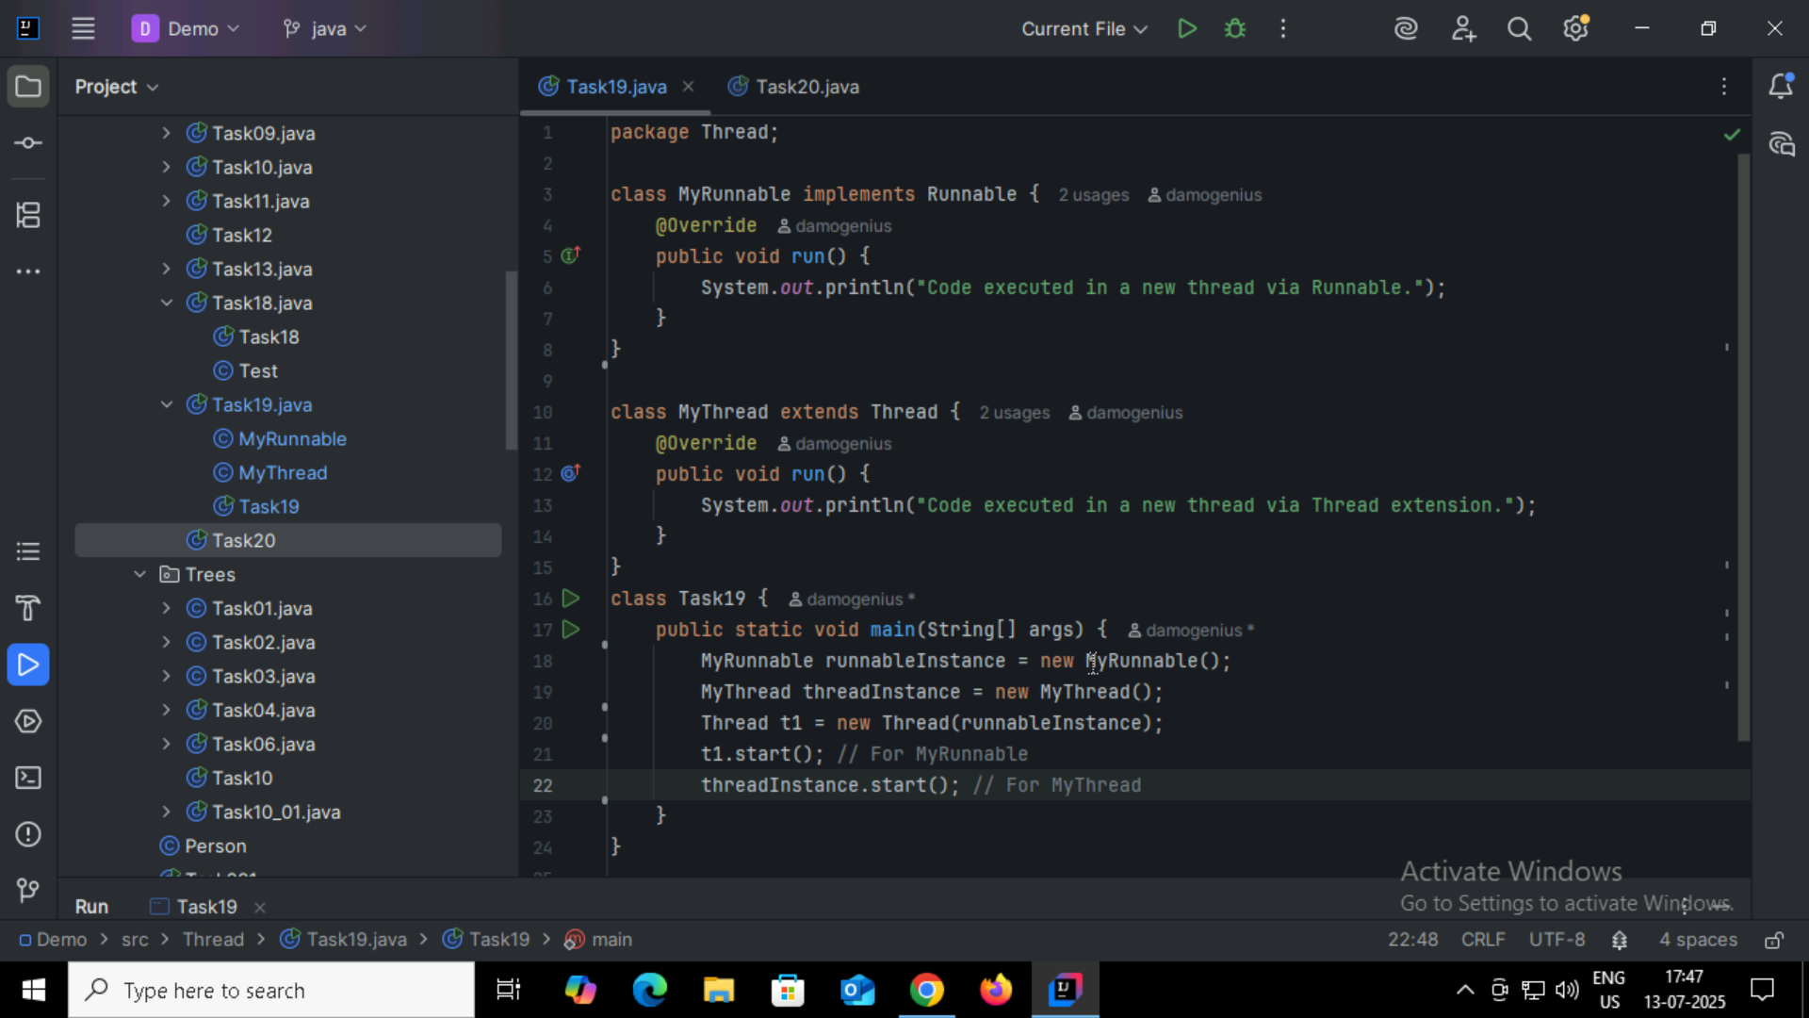

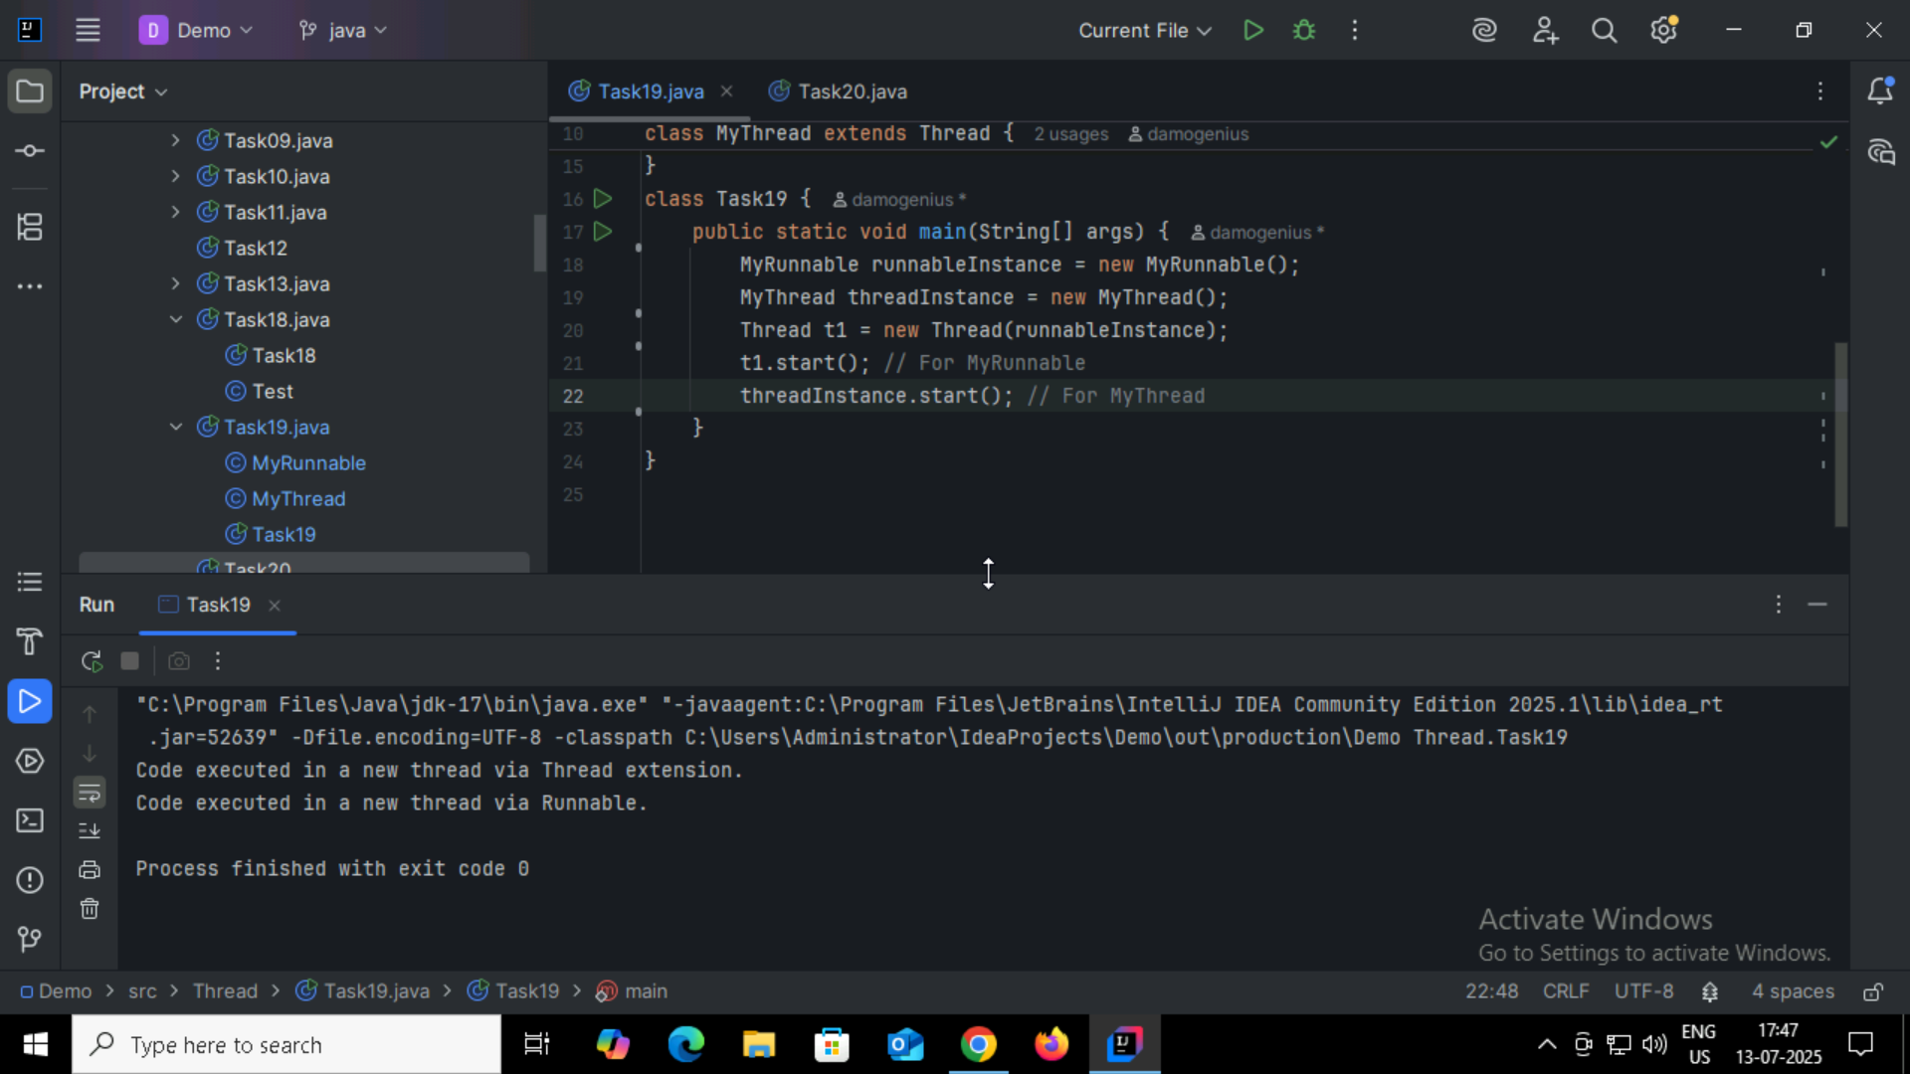

Task20:

